DSA0504-Query processing for Data Science Name: Sahasra V
Reg no:192424234

- Write a Pandas program to keep the rows with at least 2 NaN values in a given DataFrame

CODE:
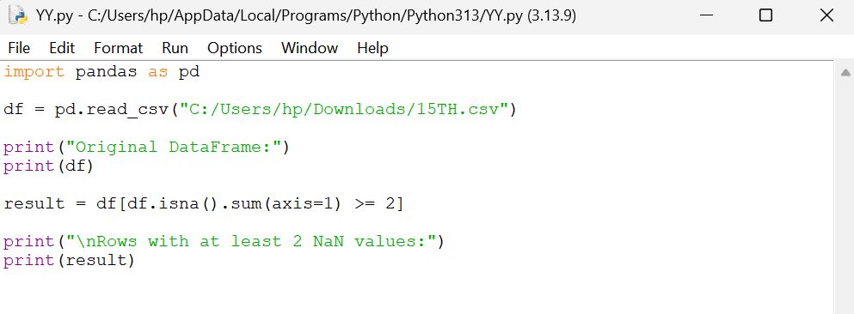

OUTPUT:
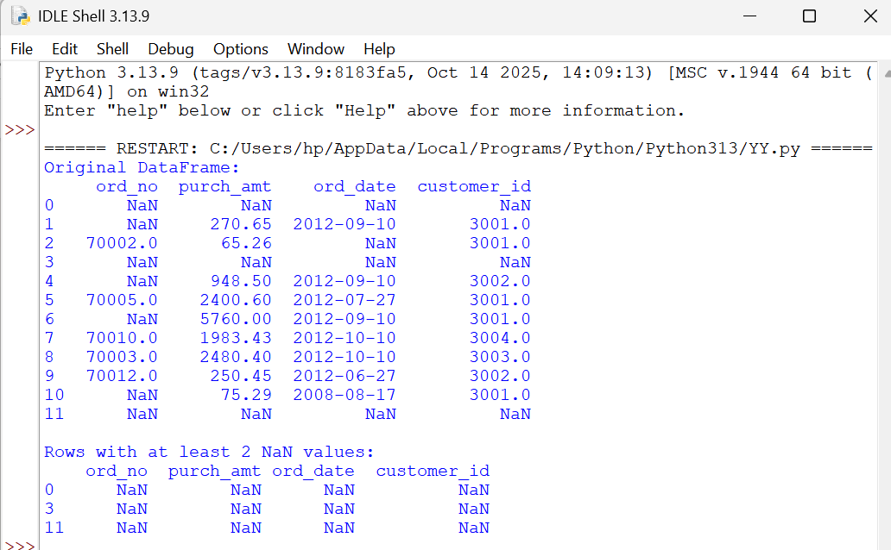

- Write a Pandas program to split the following dataframe into groups based on school code. Also check the type of GroupBy object.

CODE:
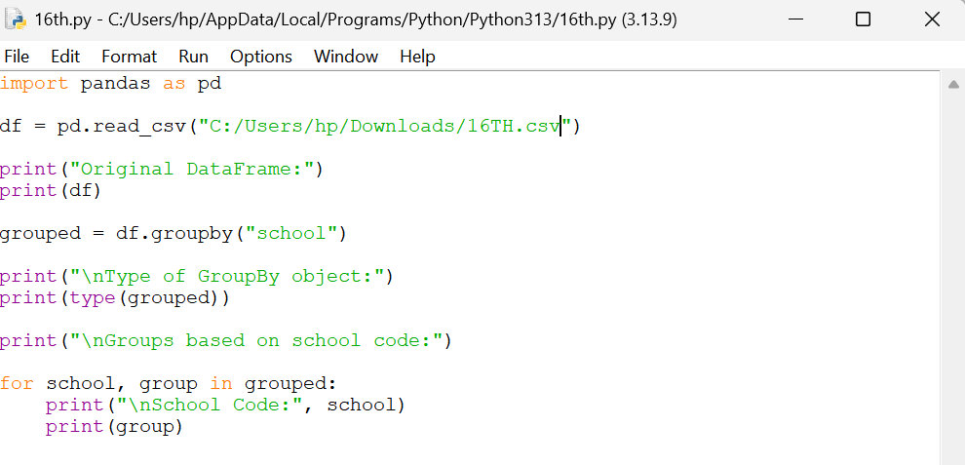
OUTPUT:

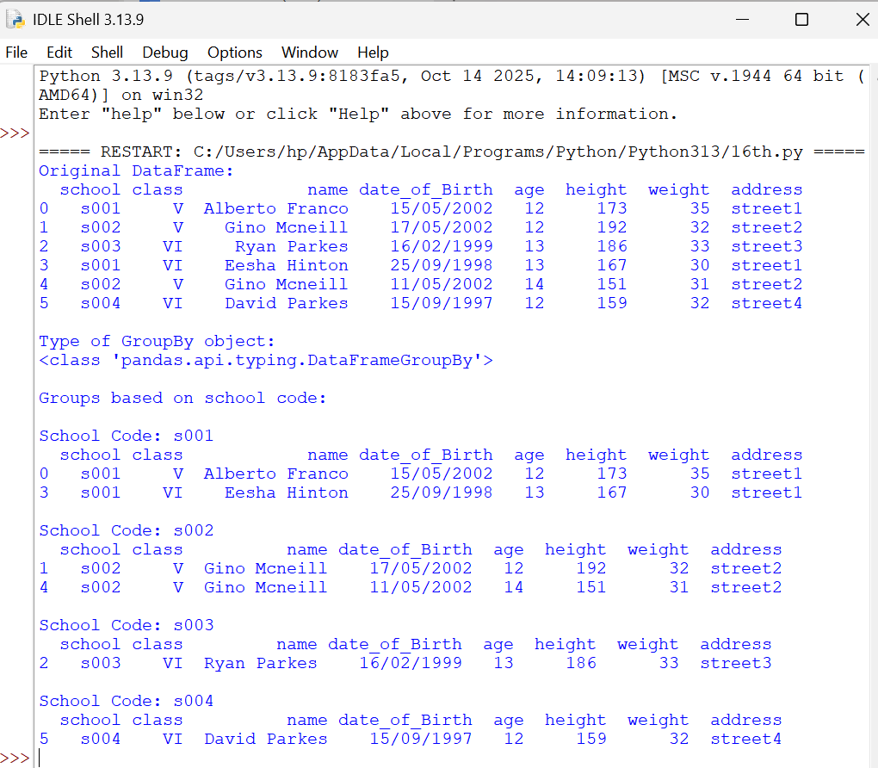

- Write a Pandas program to split the following dataframe by school code and get mean, min, and max value of age for each school.

